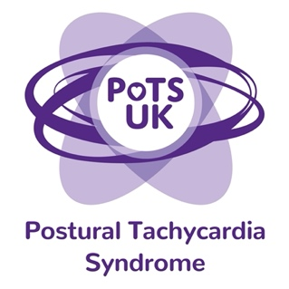
Registered Charity 1159813
www.potsuk.org
Email: parliamentarycampaign@potsuk.org

Model Press Release - Scotland

[Insert name] MP attended the PoTS UK briefing at Portcullis House on Wednesday 12th March at the request of their constituents. [Insert name] MP was shocked to learn of the inequitable access to healthcare for patients suffering with Postural Tachycardia Syndrome (PoTS) and is keen to gather more information and offer support in this area.

As a result of this meeting, [insert name] MP has committed to:
1.Writing to their Health Board demanding that they develop a care pathway for PoTS, and to ensure that there is a high-quality secondary care service available locally that patients can access when required.

2. Writing to Health Secretary Neil Gray requesting he:
- ensures a secondary care service is available to patients in every region of the UK
- and asks NHS to commission national guidelines (such as NICE and SIGN guidelines) to improve patient care and their healthcare professionals’ confidence in managing them.

The GOV.UK petition has already secured nearly 13,000 signatures. To show your support, visit: https://petition.parliament.uk/petitions/706884

