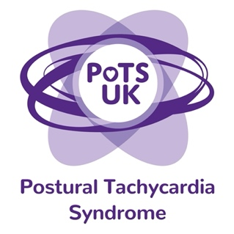
Registered Charity 1159813
www.potsuk.org
Email: parliamentarycampaign@potsuk.org

Model Press Release

[Insert name] MP has been contacted by a number of constituents about Postural Tachycardia Syndrome.

[Insert name] MP was shocked to learn of the inequitable access to healthcare for patients suffering with Postural Tachycardia Syndrome (PoTS) and is keen to gather more information and offer support in this area.

As a result, [insert name] MP has committed to:
1.Writing to their ICB or Health Board demanding that they develop a care pathway for PoTS, and to ensure that there is a high-quality secondary care service available locally that patients can access when required.

2. Writing to Health Secretary Wes Streeting requesting he:
- ensures a secondary care service is available to patients in every region of the UK
- and asks NHS to commission national guidelines (such as NICE and SIGN guidelines) to improve patient care and their healthcare professionals’ confidence in managing them.

The GOV.UK petition has already secured almost 13,000 signatures. To show your support, visit: https://petition.parliament.uk/petitions/706884

