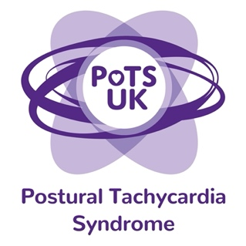
Registered Charity 1159813
www.potsuk.org
Email: parliamentarycampaign@potsuk.org

Dear [insert name of ICB]

At the request of my constituents, I recently met with PoTS UK, the national charity supporting people with Postural Tachycardia Syndrome. I was dismayed to learn of the lack of services available for patients with this condition and have pledged to support the need for significant improvements.

ICBs have a statutory responsibility to work with clinicians, service users and patient groups to commission services that meet the needs of their local population. PoTS was deemed unsuitable for specialised commissioning and therefore a secondary care service should be available within every ICB.

I am writing to ask for your assurance that you will:
1. Develop a care pathway for PoTS (Postural Tachycardia Syndrome)
2. Ensure that named high-quality secondary care services are available locally for adults and children. Some ICBs currently have no secondary care provision, and where services exist, they are currently overwhelmed and underfunded.

I have provided a summary of key issues and challenges and trust that you will take the time to read this and respond.

I would like to arrange a meeting to discuss this at your earliest convenient. Please also copy in parliamentaryaction@potsuk.org in order for the charity to be present at the meeting.
PoTS UK would be pleased to help ICBs develop care pathways, support training of healthcare professionals and offer guidance to the government.

Summary of Key Issues

The condition:
PoTS is a common, complex condition affecting both adults (often under the age of 50) and children. Multiple symptoms occur when upright and include near-fainting and blackouts, palpitations, chest pain, breathlessness, diarrhoea, vomiting, profound fatigue, cognitive dysfunction, and difficulty with exercise intolerance. Disability can be severe and has been measured as worse than that found in diabetes, cancer, COPD and HIV. Significant numbers of affected people are housebound, bed-bound or wheelchair users, and unable to work or attend school.
Access to healthcare:
Affected patients have inequitable access to healthcare. Patients often see multiple (often inappropriate) care providers across different organisations over many years before receiving confirmation of a diagnosis. Even when diagnosed, access to treatments can be limited or non-existent. The small number of existing clinicians are overburdened, and barriers further limit their ability to deliver a service to PoTS patients.
Some ICBs breech NHS commissioner/provider contracts by rejecting referrals or refusing to provide a service on spurious grounds including:
• All PoTS patients can all be managed by GPs
• PoTS is too complex and requires tertiary centre referral outside our region
• PoTS patients only need secondary care support if they faint
• No-one within our trusts wants to manage PoTS patients
• We do not accept referrals from outside our locality
• Our service is currently overwhelmed
• PoTS is not a cardiology/neurology problem
• We do not commission a service for PoTS patients

Although some affected people can be managed in primary care, many are very unwell and require access to a knowledgeable clinician and a multidisciplinary team in order to obtain a correct diagnosis and treatments that enable them to regain a reasonable quality of life and independence.

I would like to learn how you provide NHS healthcare for my constituents with PoTS.

I look forward to hearing from you.
Yours sincerely

